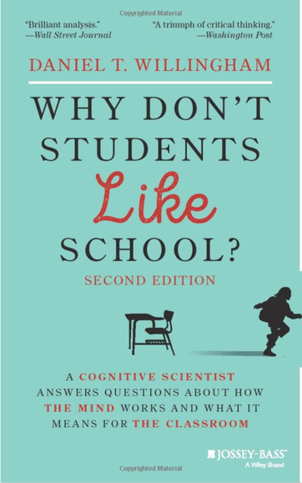
Citation:
Willingham, D.T.(2021). Why Don’t Students Like School (2nd Ed): A Cognitive Scientist Answers Questions About How the Mind Works and What it Means for the Classroom. Jossey-Bass, Hoboken, New Jersey

Abstract: (From Barnes&Noble website)

Research-based insights and practical advice about effective learning strategies
In this new edition of the highly regarded Why Don't Students Like School? cognitive psychologist Daniel Willingham turns his research on the biological and cognitive basis of learning into workable teaching techniques. This book will help you improve your teaching practice by explaining how you and your students think and learn. It reveals the importance of story, emotion, memory, context, and routine in building knowledge and creating lasting learning experiences.
With a treasure trove of updated material, this edition draws its themes from the most frequently asked questions in Willingham’s “Ask the Cognitive Scientist” column in the American Educator. How can you teach students the skills they need when standardized testing just requires facts? Why do students remember everything on TV, but forget everything you say? How can you adjust your teaching for different learning styles? Read this book for the answers to these questions and for practical advice on helping your learners learn better.
Discover easy-to-understand, evidence-based principles with clear applications for the classroom
- Update yourself on the latest cognitive science research and new, teacher-tested pedagogical tools
- Learn about Willingham’s surprising findings, such as that you cannot develop “thinking skills” without facts
- Understand the brain’s workings to help you hone your teaching skills
Why Students Don’t Like School is a valuable resource for both veteran and novice teachers, teachers-in-training, and for the principals, administrators, and staff development professionals who work with them.
Table of Contents:

Acknowledgments to the First Edition xi
Acknowledgments to the Second Edition xiii
The Author xv
Introduction xvii
Chapter 1 Why Don’t Students Like School? 1
Chapter 2 How Can I Teach Students the Skills They Need When
Standardized Tests Require Only Facts? 25

Chapter 3 Why Do Students Remember Everything
That’s on Television and Forget Everything I Say? 57

Chapter 4 Why is It So Hard for Students to Understand Abstract Ideas? 95

Chapter 5 Is Drilling Worth It? 119

Chapter 6 What’s the Secret to Getting Students to Think
Like Real Scientists, Mathematicians, and Historians? 143

Chapter 7 How Should I Adjust My Teaching for
Different Types of Learners? 167

Chapter 8 How Can I Help Slow Learners? 191

Chapter 9 How Can I Know Whether New Technology
Will Improve Student Learning? 217

Chapter 10 What About My Mind? 251

Conclusion 273

Glossary 281
Notes 285
Index 291

