Citation:
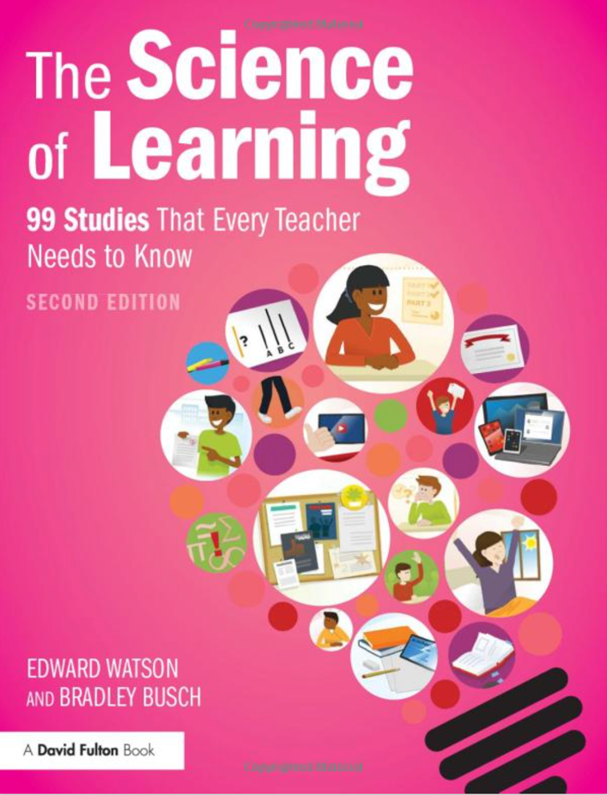
Watson, E. & Busch, B. (2021). The Science of Learning: 99 Studies That Every Teacher Needs to Know (2nd Edition). Routledge, New York.

Abstract:
Supporting teachers in the quest to help students learn as effectively and efficiently as possible, The Science of Learning translates 99 of the most important and influential studies on the topic of learning into accessible and easily digestible overviews. Building on the bestselling original book, this second edition delves deeper into the world of research into what helps students learn, with 22 new studies covering key issues including cognitive-load theory, well-being and performing well under exam pressure.
Demystifying key concepts and translating research into practical advice for the classroom, this unique resource will increase teachers’ understanding of crucial psychological research so they can help students improve how they think, feel and behave in school. From large- to small-scale studies, from the quirky to the iconic, the book breaks down complicated research to provide teachers with the need-to-know facts and implications of each study. Each overview combines graphics and text, asks key questions, describes related research and considers implications for practice. Highly accessible, each overview is attributed to one of seven key categories:
- Memory: increasing how much students remember
- Mindset, motivation and resilience: improving persistence, effort and attitude
- Self-regulation and metacognition: helping students to think clearly and consistently
- Student behaviours: encouraging positive student habits and processes
- Teacher attitudes, expectations and behaviours: adopting positive classroom practices
- Parents: how parents’ choices and behaviours impact their childrens’ learning
- Thinking biases: avoiding faulty thinking habits that get in the way of learning
A hugely accessible resource, this unique book will support, inspire and inform teaching staff, parents and students, and those involved in leadership and CPD.

My Two Cents:
What strikes me immediately about this book is that it’s in colour! I mean the inside pages are all colour.... And although this means absolutely nothing to the value of the book, it’s kind of cool. Another cool thing is how it’s written...each study—all 99—is identified by the title, “The one about...” For example, “The one about memory”, “The one about IQ and success”, “The one about marshmallows and self control” and so on. Each study takes up two pages only. Each study is summarized very briefly with the main findings given, related research and classroom implications. This is only my opinion, but I believe the authors take a ‘needs to know’ approach to the findings and implications of each study which, again in my opinion, is reductionistic in it’s approach. That is, a complex issue is reduced to its most simplistic elements. That being said, that’s exactly what the authors are promoting in their approach and it works. Teachers can read a study in two or three minutes and decide how they might apply the findings in their own classrooms. Easy, simply and will likely be useful for most classroom teachers.

