Citation:
Cantor, P., & Osher, D. (Eds.).(2021). The science of learning and development: Enhancing the lives of all young people. Routledge.

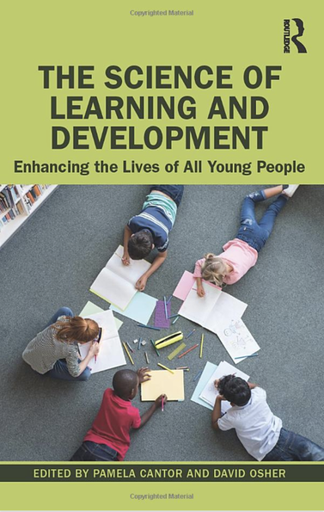
Abstract: (from the front page)

This essential text unpacks major transformations in the study of learning and human development and provides evidence for how science can inform innovation in the design of settings, policies, practice, and research to enhance the life path, opportunity and prosperity of every child. The ideas presented provide researchers and educators with a rationale for focusing on the specific pathways and developmental patterns that may lead a specific child, with a specific family, school, and community, to prosper in school and in life.
Expanding key published articles and expert commentary, the book explores a profound evolution in thinking that integrates findings from psychology with biology through sociology, education, law, and history with an emphasis on institutionalized inequities and disparate outcomes and how to address them. It points toward possible solutions through an understanding of and addressing the dynamic relations between a child and the contexts within which he or she lives, offering all researchers of human development and education a new way to understand and promote healthy development and learning for diverse, specific youth regardless of race, socioeconomic status, or history of adversity, challenge, or trauma.
The book brings together scholars and practitioners from the biological/medical sciences, the social and behavioral sciences, educational science, and fields of law and social and educational policy. It provides an invaluable and unique resource for understanding the bases and status of the new science, and presents a roadmap for progress that will frame progress for at least the next decade and perhaps beyond.

Table of Contents:

(below: next page)

