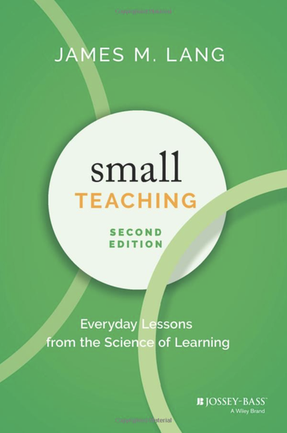
Citation:
Lang, J.M. (2021). Small Teaching: Everyday Lessons from the Science of Learning (2nd Ed): Jossey-Bass, Hoboken, New Jersey.

Abstract:
Note: Though Lang’s audience is intended to be instructors of higher education, the material in this book is easily applied to K-12 settings.
A freshly updated edition featuring research-based teaching techniques that faculty in any discipline can easily implement
Research into how we learn can help facilitate better student learning—if we know how to apply it. Small Teaching fills the gap in higher education literature between the primary research in cognitive theory and the classroom environment. In this book, James Lang presents a strategy for improving student learning with a series of small but powerful changes that make a big difference―many of which can be put into practice in a single class period. These are simple interventions that can be integrated into pre-existing techniques, along with clear descriptions of how to do so. Inside, you’ll find brief classroom or online learning activities, one-time interventions, and small modifications in course design or student communication. These small tweaks will bring your classroom into alignment with the latest evidence in cognitive research.
Each chapter introduces a basic concept in cognitive research that has implications for classroom teaching, explains the rationale for offering it within a specific time period in a typical class, and then provides concrete examples of how this intervention has been used or could be used by faculty in a variety of disciplines. The second edition features revised and updated content including a newly authored preface, new examples and techniques, updated research, and updated resources.
- How can you make small tweaks to your teaching to bring the latest cognitive science into the classroom?
- How can you help students become good at retrieving knowledge from memory?
- How does making predictions now help us learn in the future?
- How can you build community in the classroom?
Higher education faculty and administrators, as well as K-12 teachers and teacher trainers, will love the easy-to-implement, evidence-based techniques in Small Teaching.

First thoughts:
I won’t go into a lot of detail here on my first thoughts, but I love how this book frames Lang’s intentions...which he borrows from one of my favourite books:

“Much of what we’ve been doing as teachers and students isn’t serving us well, but some comparatively simple changes could make a big difference”
Make it Stick: The Science of Successful Learning (p.9)
And so, Lang states his approach immediately; look to alter teaching in our day to day careers by addressing what we know from the Science of Learning in small, immediately implementable and manageable ways...small teaching. It’s attainable, it’s attractive and it’s effective. This book is excellent for all teachers...and their students.

Table of Contents:

