GoodTeaching.ca
Evidence-based teaching practices that enhance learning

The Amazing Power of Quizzing
Quizzing as a teaching practice? Yes, in fact, using frequent quizzing—or retrieval practice as it’s known, is a powerful tool that contributes to information being consolidated into long term memory. Frequent quizzing is one of a teacher’s most powerful tools to increase learning, and it can be embedded in a teacher’s daily routine as part of their teaching repertoire. “Retrieval practice—recalling facts or concepts or events from memory...strengthens the memory and interrupts forgetting” (Brown, Roediger & McDaniel, 2014).
?

Quizzing interrupts forgetting! Quizzing strengthens the memory!

What’s the gist of this teaching approach?
I don’t blame you if the first thing you think of when I say quizzing is a negative association with standardized testing, an over-reliance on rote learning, test anxiety, cramming or regurgitation of facts in order to get a good mark, only to realize that nothing was actually learned. That’s not what cognitive psychologists actually promote when they praise the powerful effects of quizzing.

Think of it this way; no-stakes, quick and fun quizzing simply to see how much students remember. No pressure, no comparing to others, no marks. Coaches do it every day (e.g., show me how you receive that pass), driving instructors do it, parents do it, and we do it to ourselves (e.g., where did I put my keys?). Without even knowing it we are strengthening memory when we quiz ourselves or actively try to recall something from memory.

But here’s the key, it should take effort. We simply don’t quiz students on what they already know, or what they are temporarily holding in their short-term working memory. That doesn’t actually result in learning. No, instead, good quizzing involves a degree of effort to recall information, or what some researchers call desirable difficulty. Effort in recall strengthens neural pathways.
!
Research into retrieval practice has demonstrated time and again through rigorous randomized control trials that students who participate in retrieval practice experience deeper learning than students who do not....every time! Quizzing requires that the brain rehearses, seeks and finds, and recalls where it stored information. By forcing the brain to frequently ‘retrace its steps’ scientists say we strengthen neural pathways for future ease of recall.

Can it really be as simple as that? Yes it can! However, teachers and students have come to associate this simple act of retrieval practice with a lot of negative emotions and experiences related to other testing approaches. Quizzing (retrieval practice) can be one of the most enjoyable and rewarding aspects of learning if used as its intended, especially if it’s used within a classroom culture where error and mistakes are normalized and quizzing is low-or-no stakes for the purpose of simply determining if we remember the information or not.

Retrieval practice is a deliberate act of asking students to try to retrieve information from long term memory, to recall it, often-times (but not necessarily) without studying it beforehand, to determine how much students remember. The very act of practicing retrieval serves to strength the neural networks of encoding and recall, and research has shown that it leads to deeper learning.

We know too that learning is deeper and more durable when it is effortful. Simply rereading our notes or underlining or highlighting passages in a paper may seem to be a good way to study material for later recall, but they are ineffective and unproductive. They are actually a very poor way to study. However, making the brain to work and try to recall information from memory is a better way to develop the brain’s capacity to remember information.

Putting the brain to work in trying to recall information on a regular basic is necessary for learning because this process interrupts forgetting. Retrieval practice strengthens neural networks involved in the encoding, storage and retrieval of information for later use.

A definition of learning from Make it Stick; The Science of Successful Learning is this: “Learning is acquiring knowledge and skills and having the readily available from memory so you can make sense of future problems and opportunities.” In order for knowledge and skills to be readily available from long term memory for later use, the brain has to be engaged in frequent retrieval practice to strengthen the neural pathways that aid in remembering that information.

How can teachers put it into practice?
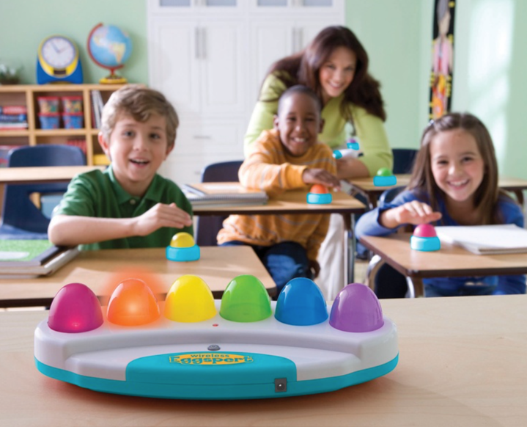
As long as teachers keep the principle of retrieval practice at the centre of what they do, they can have fun with the idea. Using any form of quizzing or on-the-spot practice will do. What’s most important to keep in mind is this: quizzing is a form of learning...it should not be seen as a waste of time or an addition to regular teaching...it IS teaching. Second, it must be frequent...daily, multiple times per day if possible. It can be for just one person at a time or for the entire class. It can be scripted or unscripted, planned in advance or spontaneous. The idea here is to get students to practice recalling information so that their brains work to retrieve it. Thirdly, it must be effortful or have a degree of desirable difficulty in order to be effective. Finally, it will involve error and mistakes and forgetting. That’s fine because you will then employ corrective feedback to help fill in the memory gaps...and this process too leads to deeper learning. As long as teachers help students to embrace and accept a culture of learning through development, mistake-making, corrective feedback and some forgetting, retrieval practice will contribute to considerable learning.
Source: Microsoft Bing Images

The options are limitless. For example, if students have smartphones and are permitted to use them, Apps such as Kahoot!, Mentimeter, and Quizziz are great to use for any-time quizzing. Teachers don’t need to rely on technology though. I’ve quizzed my students hundreds of times with everything from rapid-fire questions to elaborate Trivial Pursuit style gameshows. We've had friendly team competitions to individual ‘show me what you know’ types of set ups. I’ve been involved in drama productions where students were quizzed frequently on their lines and movements, I’ve coached students in physical education class about how to line up for a basketball shot and how to smash a badminton bird. The idea here is to ask a student to recall information you’ve taught them in a non-threatening way. Quizzes are simply a part of everyday learning, so classroom teachers should incorporate them as a frequent teaching method.

What else should teachers think about?
Teach students the value of retrieval practice. That’s right, teach your students the Science of Learning involved in quizzing, retrieval practice, memory development, desirable difficulty, the value of mistakes and error making and the expectation that the classroom is a place for trial and error.
Promote retrieval practice as a lifelong learning process. Teachers can help students learn how to self-test and quiz themselves for the purpose of self-regulation and self-monitoring. Although not promoted in this paper on quizzing, retrieval practice that is spread out over time leads to even better learning. Spaced practice, as it’s called, is the opposite of cramming for a test. Teaching students the value and science behind spacing their retrieval practice out over time will lead to greater satisfaction for students and certainly better learning. Teaching students how to study is also important. Using methods that require recall (e.g., flashcards with the question on one side and the answer on the other side) instead of simply rereading material leads to greater retention of information. When a student rereads information over and over and over (massed practice) there is a false sense of comprehension and memory that occurs...although it can result in better regurgitation of information on a test. Practicing a little bit each day over a period of time, or spaced practice, actually leads to better long term retention.
No stakes, low stakes, study before hand or not. The idea of retrieval practice is to make the brain work to recall information. By giving students multiple opportunities to try to recall information from memory we are actually helping their brain consolidate this information into long term memory. Allowing these quizzes to cost them nothing, students do not fret or worry about the marks associated with quizzing. It’s a win-win situation; they learn the material at no cost to them. Teachers can ask their students to study material to be quizzed on, of course, but this may present a false sense of understanding or knowledge if cramming results in quick forgetting immediately after a quiz. It would be better for a teacher to have two quizzes; one the day after studying and then one quiz unannounced the following week that’s not worth any marks perhaps. Adding frequent study to a culture of frequent quizzing leads to greater learning. A good example of this to follow the behaviour of a teenager learning to advance through various levels of their favourite video game. Gaming scenarios such as this involve hundreds of mistakes and retries. Students have little success at first, but keep trying because it's just a game (low stakes) and it’s enjoyable, novel and rewarding, so they try and try again until they master the tools of the game (e.g., weapons, racetrack familiarity, location knowledge, tricks and shortcuts, etc.).
Corrective Feedback. Corrective feedback or formative assessment helps teachers and students know if they understand or can use the skill or curriculum. Corrective feedback is extremely useful in filling in the gaps of memory. Research has demonstrated time and again that even though students will make many mistakes during retrieval practice, it’s not the mistakes that stay in their long term memory once they are given corrective feedback (e.g.,a bad academic habit). Instead, corrective feedback helps the brain discard the mistake and sort it from correct trials.

What evidence is there to support this? Where can I go to learn more?
There are simply too many cognitive scientists and research articles currently available to provide list in this space. However, to get you started I’d like to introduce you to a great website, book and article. Three resources that have thousands of follow up links, articles and resources.

Book

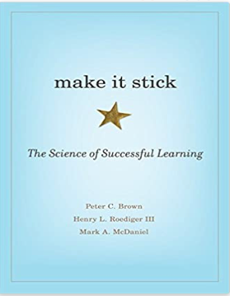
Make it Stick: The Science of Successful Learning by Peter C. Brown, Henry L. Roediger, III, and Mark A. McDaniel

Article

Karpicke, J. D. (2016, June). A powerful way to improve learning and memory. Psychological
Science Agenda. https://www.apa.org/science/about/psa/2016/06/learning-memory
https://www.apa.org/science/about/psa/2016/06/learning-memory

Website

https://www.retrievalpractice.org

What evidence is there to support this? Where can I go to learn more?

There are simply too many cognitive scientists and research articles currently available to provide you in this space. However, to get you started I’d like to introduce you to a great website, book and article. Three resources that have thousands of follow up links, articles and resources.

Book

Make it Stick: The Science of Successful Learning by Peter C. Brown, Henry L. Roediger, III, and Mark A. McDaniel

Article

Karpicke, J. D. (2016, June). A powerful way to improve learning and memory. Psychological
Science Agenda. https://www.apa.org/science/about/psa/2016/06/learning-memory
https://www.apa.org/science/about/psa/2016/06/learning-memory

Website

https://www.retrievalpractice.org

