Citation:
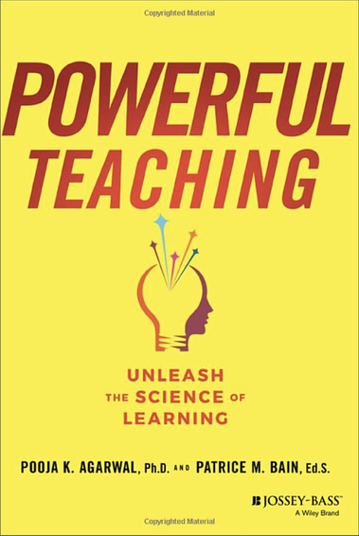
Agarwal, P.K, & Bain, P.M. (2019). Powerful teaching: Unleash the science of learning. Jossey-Bass

Abstract:
Powerful Teaching: Unleash the Science of Learning empowers educators to harness rigorous research on how students learn and unleash it in their classrooms. In this book, cognitive scientist Pooja K. Agarwal, Ph.D., and veteran K–12 teacher Patrice M. Bain, Ed.S., decipher cognitive science research and illustrate ways to successfully apply the science of learning in classrooms settings. This practical resource is filled with evidence-based strategies that are easily implemented in less than a minute—without additional prepping, grading, or funding!
Research demonstrates that these powerful strategies raise student achievement by a letter grade or more; boost learning for diverse students, grade levels, and subject areas; and enhance students’ higher order learning and transfer of knowledge beyond the classroom. Drawing on a fifteen-year scientist-teacher collaboration, more than 100 years of research on learning, and rich experiences from educators in K–12 and higher education, the authors present highly accessible step-by-step guidance on how to transform teaching with four essential strategies: Retrieval practice, spacing, interleaving, and feedback-driven metacognition.
With Powerful Teaching, you will:
- Develop a deep understanding of powerful teaching strategies based on the science of learning
- Gain insight from real-world examples of how evidence-based strategies are being implemented in a variety of academic settings
- Think critically about your current teaching practices from a research-based perspective
- Develop tools to share the science of learning with students and parents, ensuring success inside and outside the classroom
Powerful Teaching: Unleash the Science of Learning is an indispensable resource for educators who want to take their instruction to the next level. Equipped with scientific knowledge and evidence-based tools, turn your teaching into powerful teaching and unleash student learning in your classroom.

See next page for Table of Contents

