Citation:
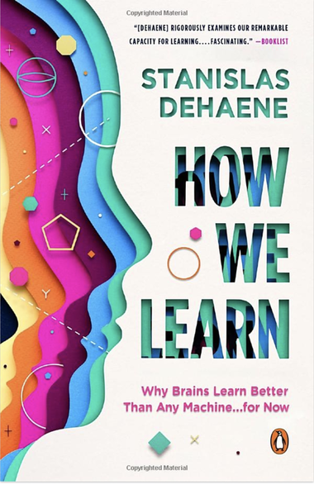
Dehaene, S. (2020). How we learn: Why brains learn better than any machine...for now. Viking Press, Penguin Random House.

Abstract:

An illuminating dive into the latest science on our brain's remarkable learning abilities and the potential of the machines we program to imitate them
The human brain is an extraordinary learning machine. Its ability to reprogram itself is unparalleled, and it remains the best source of inspiration for recent developments in artificial intelligence. But how do we learn? What innate biological foundations underlie our ability to acquire new information, and what principles modulate their efficiency?
In How We Learn, Stanislas Dehaene finds the boundary of computer science, neurobiology, and cognitive psychology to explain how learning really works and how to make the best use of the brain’s learning algorithms in our schools and universities, as well as in everyday life and at any age.

Feedback on How We Learn from Dr. Rebecca Gotlieb

What is learning and how do we accomplish it? Stanislas Dehaene, a cognitive neuropsychologist and professor at the Collège de France, addresses these questions in How We Learn: Why Brains Learn Better Than Any Machine… for Now. He defines learning as the process of forming an internal model of the outside world and describes four critical elements of learning—attention, active engagement, error feedback, and consolidation. Human brains are more efficient learners than computers or other species because they are so skilled in reasoning about probabilities and extracting abstract principles from observations. Our ability to learn, especially from one another, allows us to adapt to unpredictable circumstances and is responsible for our success as a species. This book will be of interest to individuals wishing to better understand learning, how humans do it well, and implications of brain development and functioning for learning.

Dehaene contends that babies are not born as blank slates, which is important since learning requires possessing a model of the world. Further, they efficiently refine their naïve theories with experience. He reviews evidence showing that babies are born with evolutionarily programmed knowledge about, for example, the continuity of time and space, relative quantities, and the importance of faces. Additionally, learning (e.g., of language) starts in the womb.
Just as babies are born with theories about the world, they are born also with major brain structures are already in place. Still, brain development is experience dependent. Dehaene discusses “sensitive periods,” or periods of time when brain areas are especially plastic. Areas of the brain involved in supporting our senses lose plasticity first, while areas involved in our most complex cognitive functions remain plastic the longest. He argues that only extreme brain differences affect differences in cognition and that generally there is only minor variability among peoples’ brains. He shows also that there is never complete determinism from genes; experience and learning can significantly change the brain.
For more from Dr. Gotlieb about this book, go to https://www.learningandthebrain.com/blog/how-we-learn-why-brains-learn-better-than-any-machine-for-now-by-stanislas-dehaene/

Table of Contents